Problem 1

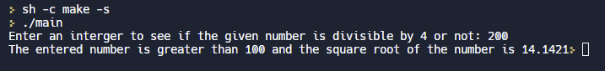

Problem 2

Problem 3

Problem 4

